# VISA: PROJECT CASE STUDY

## Introduction

Design and develop an application to display details of products. The user can

1. View the products
2. Filter the products
3. View particular product details

## Instructions and Assumptions

* Assume that the application is a single user system. So no explicit user management or security related implementation required.
* Product details are as follows: image, name, unique code, available from data, price and rating [view diagram for better understanding]
* The application must be implemented using ¾ (n) tier architecture
  + User interface - ASP.NET MVC Web Page technology/ ASP.NET MVC Core technology (web page)
  + Data access layer: Entity Framework and LINQ
  + Business Layer: business logic (LINQ if necessary)
  + Service Layer: ASP.NET MVC Web API/ ASP.NET MVC Web API Core
  + Static Product data should be saved in a plain text file using JSON array format or persisted in SQL Server Database tables
* One should follow the Test Driven Development approach, where you first identify all possible combinations of flow of execution of business or application logic and target for testing every possibility by writing the unit test. Then you start implementing the actual logic one by one and run the unit test before continuing with the next.
* Unit test methods should also cover the negative/exception flows for the completeness.
* ASP.NET MVC Web API/Core methods should be called from UI asynchronously
* Dependency injection must be used
* Visual Studio 2017 IDE can be used to develop the application
* HTML5, CSS3, Bootstrap, SASS, jQuery should be used wherever possible

## System Features

1. When you run the application the application displays the welccome message

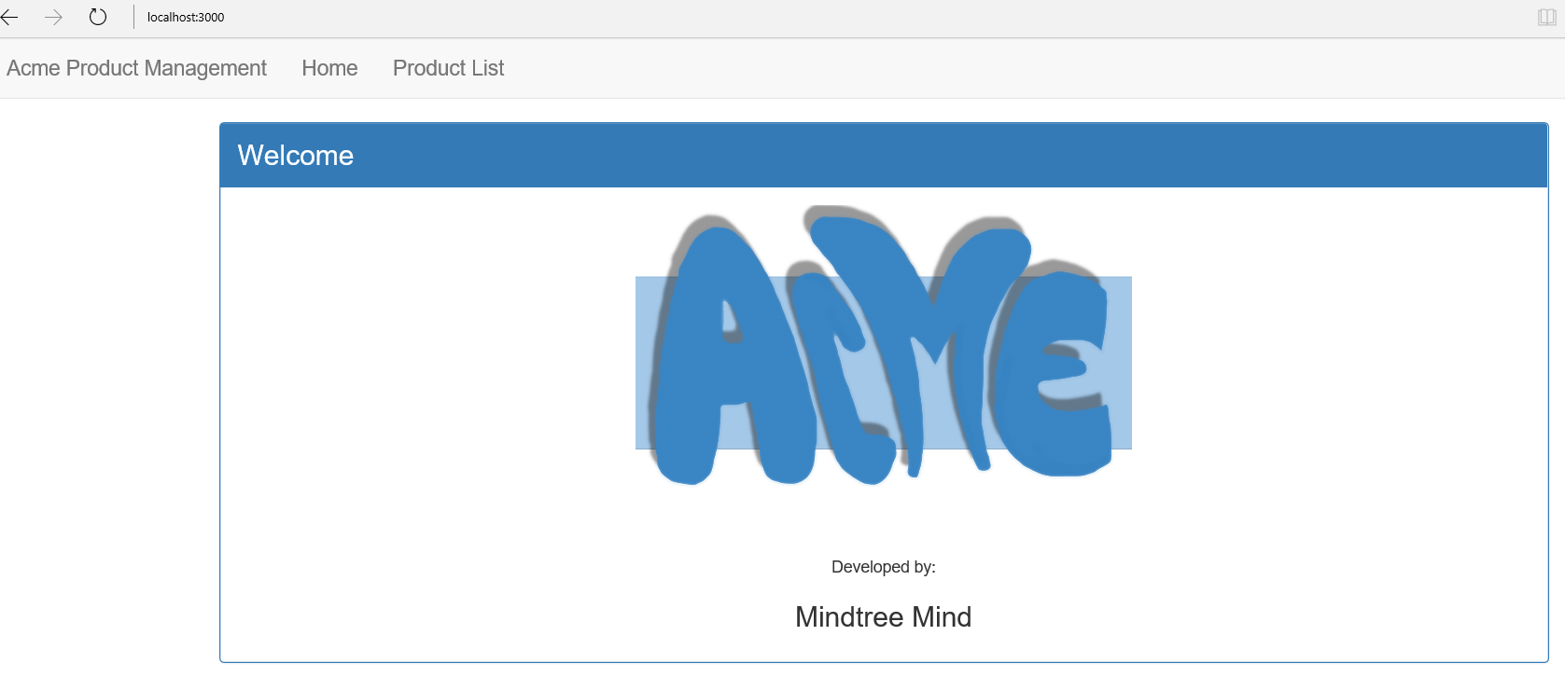

1. Clicking on ‘Home’ link actually leads to the welcome view. The route for this view is:

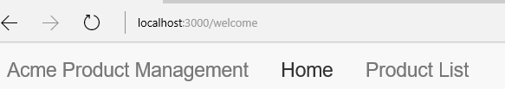

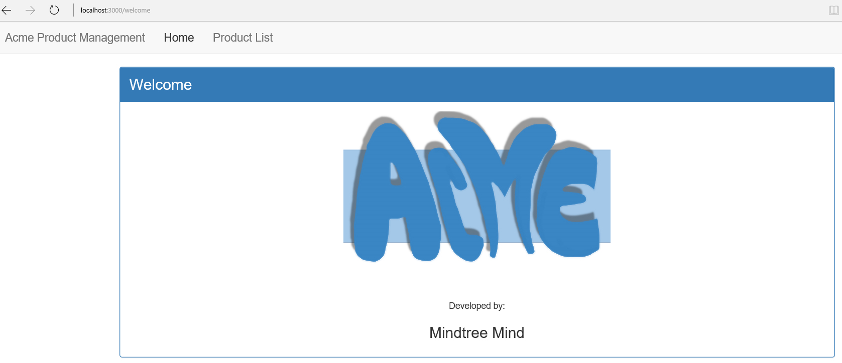

1. Clicking on the ‘Product List’ will leads user to the products view. This view displays product details using a tabular structure and image, name, unique code, available from, price and rating of the products are displayed in that table. How many asterisks will be used to display the rating of the product is calculated based on the rating value of the product dynamically.

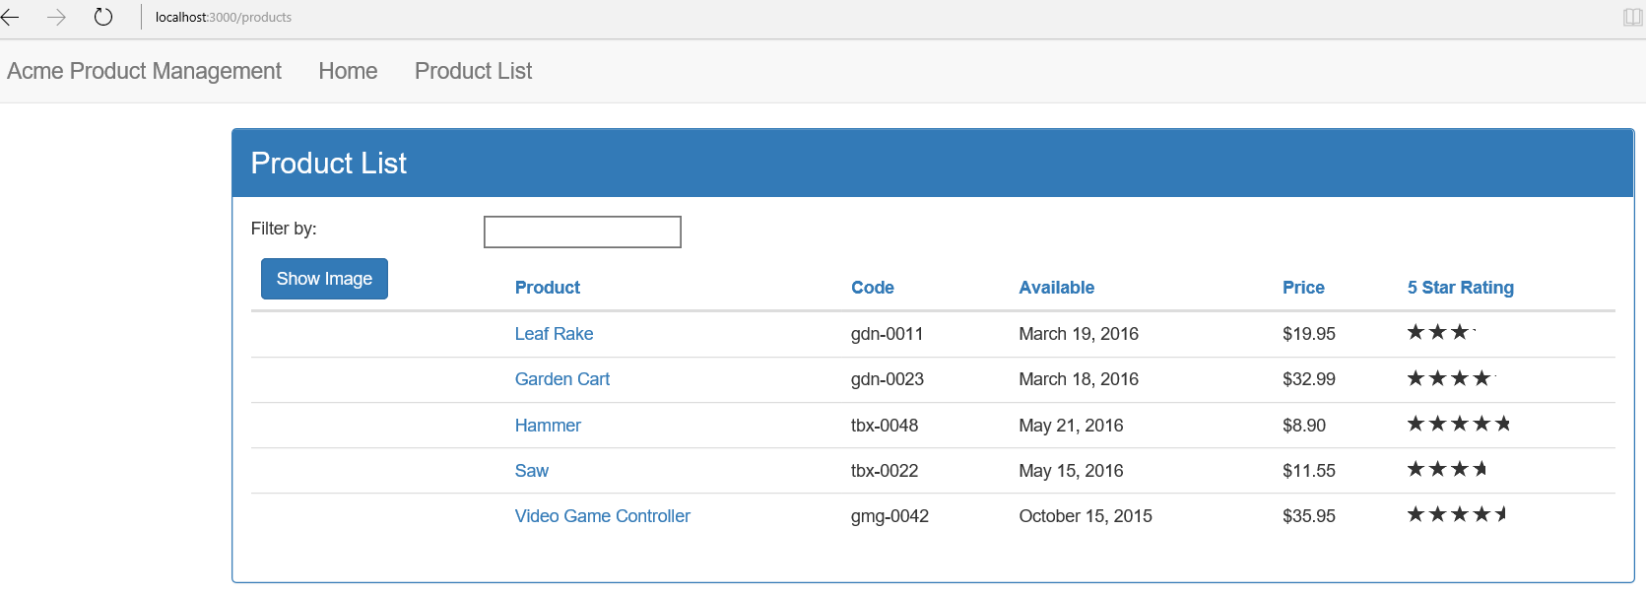

1. The route for the ‘Product List’ view is

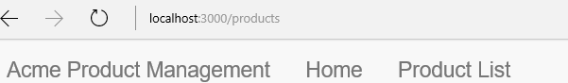

1. Initially the image of products are not displayed. But clicking on ‘Show Image’ button will display the images and immediately the text on the button will change to ‘Hide Image’. Upon clicking the button again will hide the image and the text on the button will change to ‘Show Image’ from ‘Hide Image’.

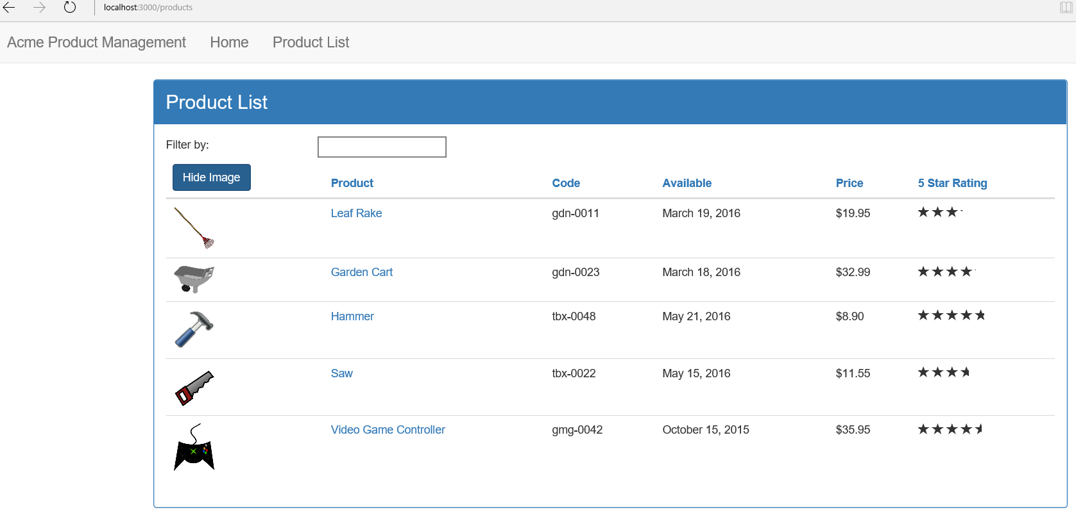

1. If user enters any text in the text box referred as ‘Filter By:’, then the products are filtered by the text. Also, the ‘Filtered By:’ label display the text that you have used to filter the products.

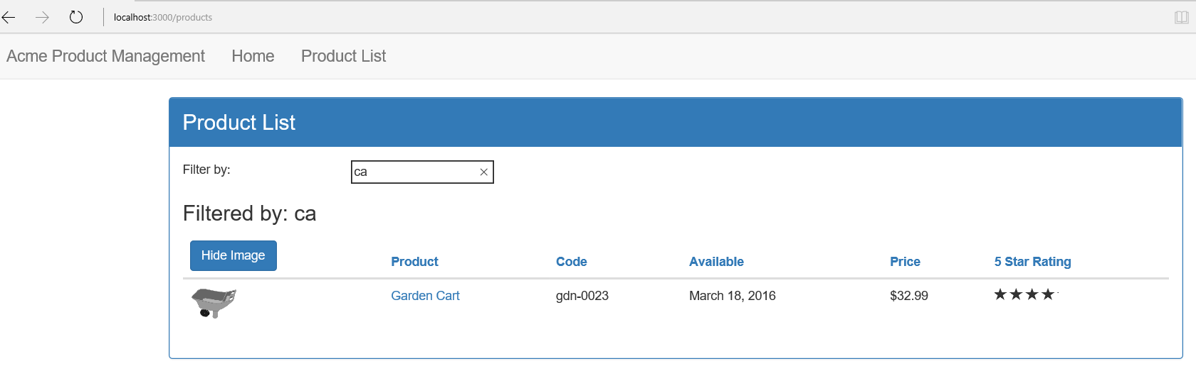

1. Clicking on the name of product (under ‘Product’ column in the table) will lead you to another view, which displays the complete details of the product.

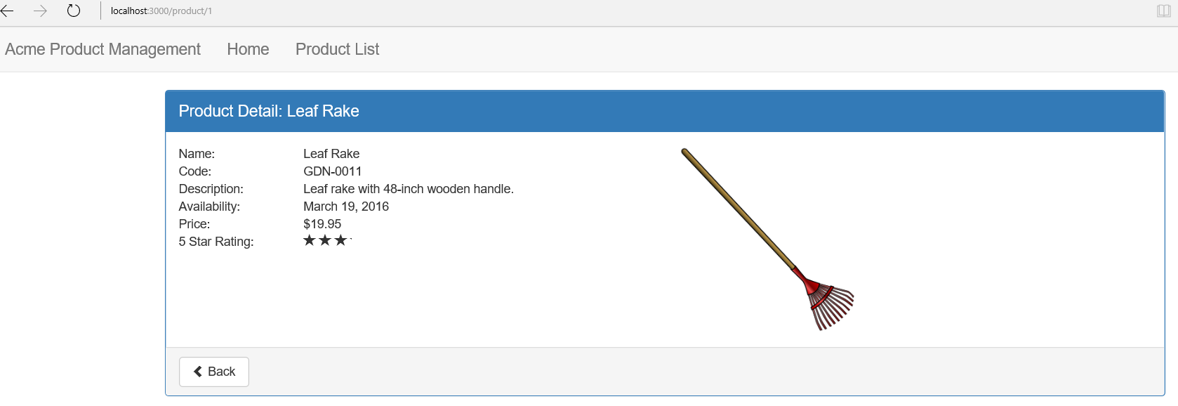

1. The route for this view is as follows:

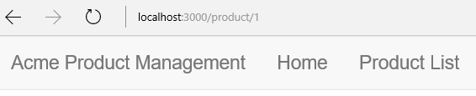

1. Clicking on back button will lead user to the Product List view.

